H.T No
Regulations:
A17


Sreenidhi Institute of Science and Technology
(An Autonomous Institution)
Code No: 6K402 Date: 28-May-2019 (FN)

B.Tech II Year II-Semester External Examination, May/June-2019 (Regular)
STRUCTURAL ANALYSIS-I (CIVIL)

Time: 3 Hours Max.Marks:75

Note: a) No additional answer sheets will be provided.
b) All sub-parts of a question must be answered at one place only, otherwise it will not be valued.
c) Missing data can be assumed suitably.

Part - A Max.Marks:25

Answer all QUESTIONS.

1. | What are the advantages and disadvantages of indeterminate structures? | [3M]
2. | State Castigliano’s first and second theorems. | [3M]
3. | Write the slope deflection equation including the settlement of support. | [3M]
4. | What do you mean by distribution factor and write the formula for the same? | [3M]
5. | Write the procedure for kanis method. | [3M]
6. | A fixed beam AB is subjected to an end clockwise rotation θ at A. Flexural rigidity is EI and span is L. What is fixed end moment at B. | [2M]
7. | What are the limitations of Castigliano’s theorem? | [2M]
8. | Write the general slope deflection equations for the end moments in terms of fixed end moments due to applied loading on the beam, stiffness of the member and end rotations. All the supports are at the same level. | [2M]
9. | What is the degree of indeterminacy of propped cantilever? | [2M]
10. | What do you mean by degree of indeterminacy? | [2M]
Part – B Max.Marks:50
ANSWER ANY FIVE QUESTIONS. EACH QUESTION CARRIES 10 MARKS.

11. |  | A prop for cantilever of uniform flexural stiffness is proposed at the remote end. Find the load on the prop when a force W is applied at the centre of the cantilever. | [10M]
12. |  | Find the force in the member BC of the frame loaded as shown in Figure 1. All the members have the same cross sectional area.  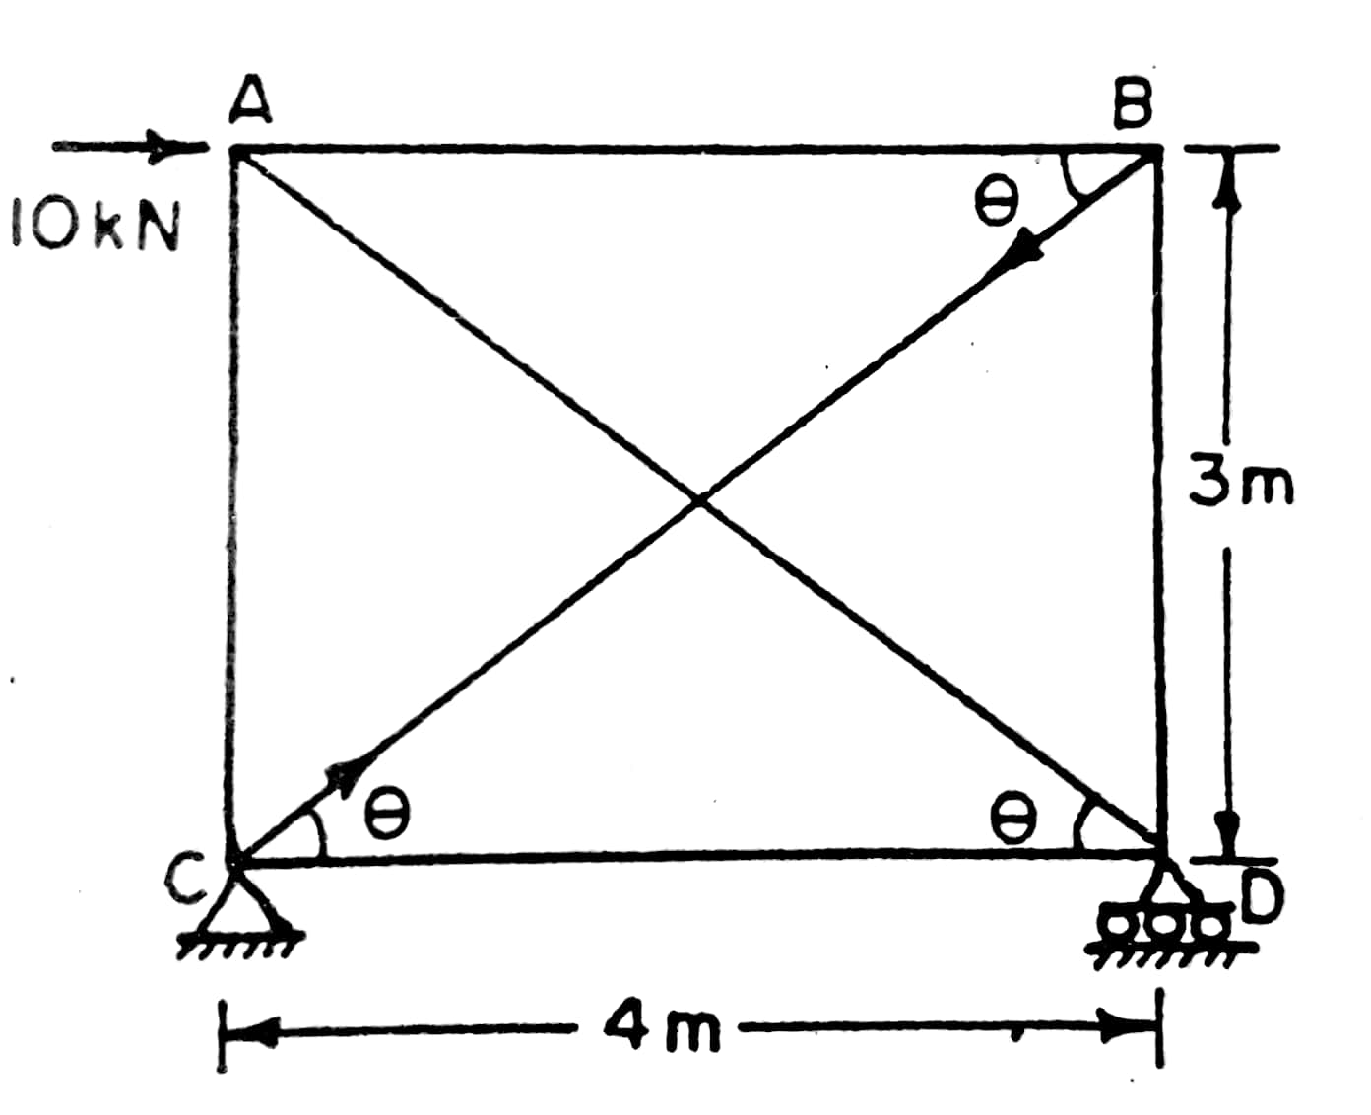  Figure 1 | [10M]
13. |  | Analyze the rigid joint frame shown in Figure 2 by the slope deflection method. Draw the bending moment diagram.  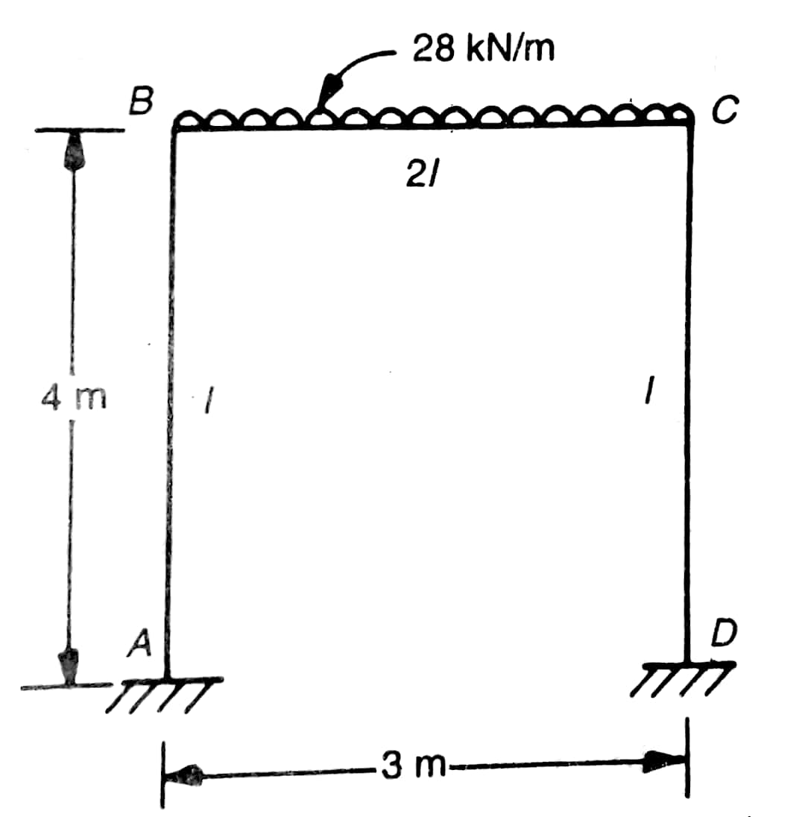  Figure 2 | [10M]
14. |  | Analyze the continuous beam shown in Figure 3 by the moment distribution method if the support sinks by an amount of 7.5 mm. Draw the shear force and bending moment diagrams. Take EI = 48000 kNm².  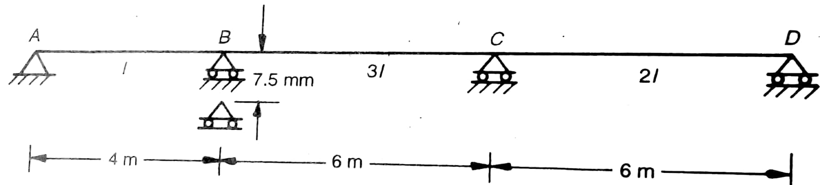  Figure 3 | [10M]
15. |  | Analyze the portal frame shown in Figure 4 by Kani’s method. Draw the bending moment diagram.  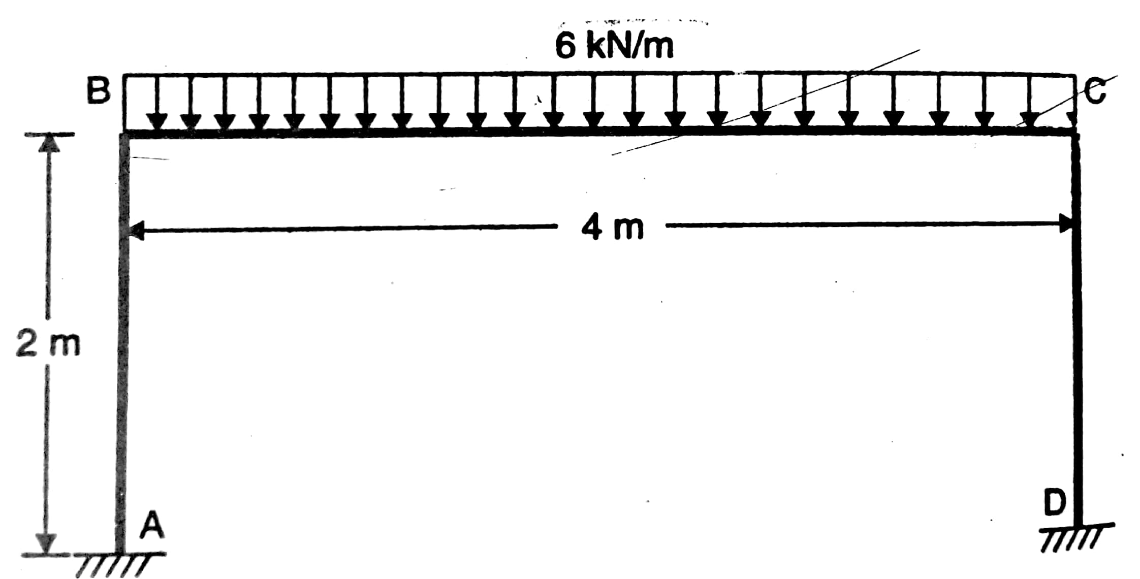  Figure 4 | [10M]
16. |  | For the propped cantilever shown in Figure 5, find the support reaction and plot the bending moment diagram.  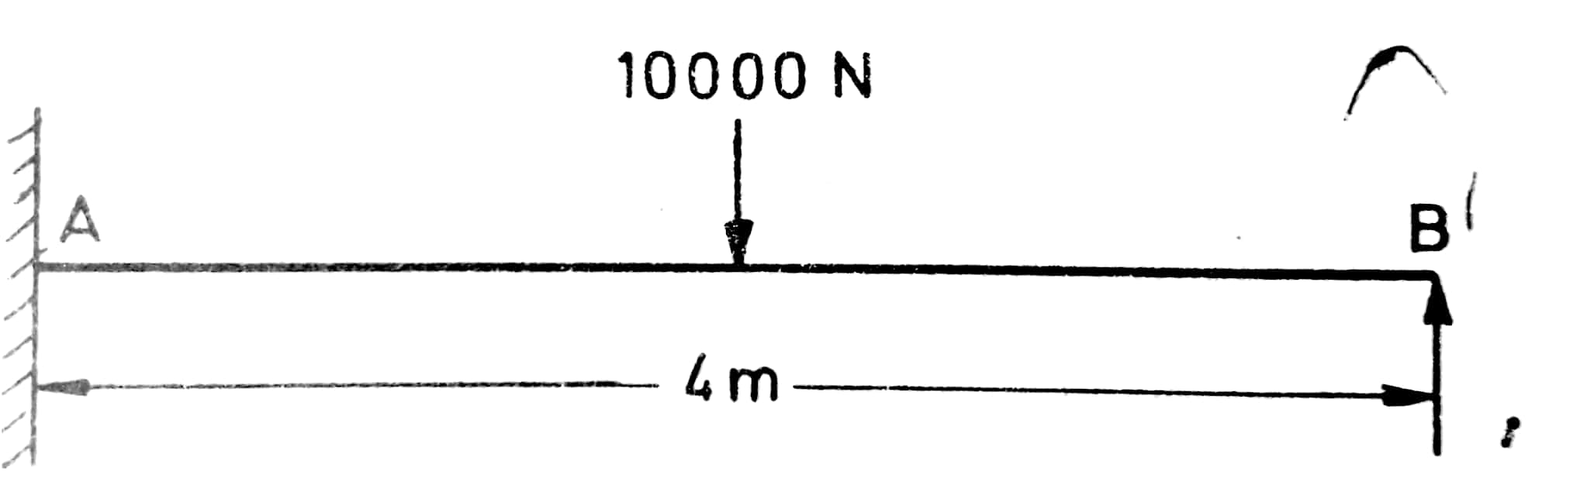  Figure 5 | [10M]
17. |  | Analyze the non-prismatic fixed beam shown in Figure 6 by the slope deflection method. Draw the bending moment diagram.  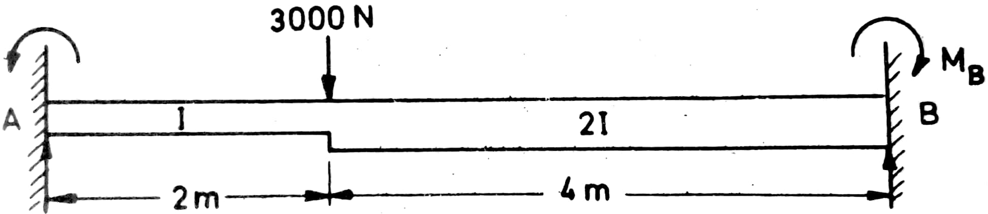  Figure 6 | [10M]
18. |  | Find the fixed end moments and plot the shear force and bending moment diagrams for the beam loaded as shown in Figure 7.  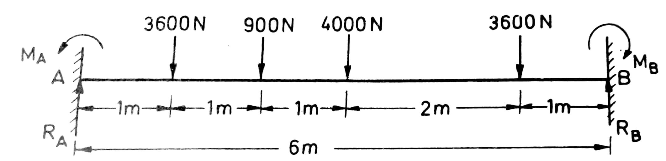  Figure 7 | [10M]

-- 00 -- 00 –

